Northwest Ohio Baptist Association
“KINGDOM CONNECTIONS”
March 2020

NW Ohio Churches on Mission to Reach One Million , One Life at a Time

Association Semi-Annual meeting
Monday, March 30
Second Baptist, Defiance
6 PM light supper & fellowship
6:45 Business Meeting

SCHOLARSHIP
The James Eldridge Scholarship provides financial assistance to applicants recommended by their own home church and that are affiliated with the Northwest Ohio Baptist Association. Scholarship funds will be awarded directly to colleges, Bible schools, universities, seminaries. For further information or for an application contact the Association office at 419-243-1255 or janetbartusnwo@gmail.com.
Applications need to be submitted by June 1, 2020

ONLINE TAX WEBINAR
for churches & pastors
Do you have a tax question? It's the perfect venue to get your tax questions answered. Our annual tax webinars provide churches an update regarding tax changes that may affect their churches and pastors filing requirements. Register at https://www.scbo.org/event/annual-tax-webinar
When you register for the webinar we will be asking you to contribute some of your top tax questions so we can address them during the webinar. We are also providing a free copy of the 2019 Church Financial Guidebook to every attendee of this year’s webinar. The Church Financial Guidebook is a valuable resource to church treasurers, financial secretaries, finance committees and pastors.
If you are unable to attend the webinar and would like to submit a question or need more information regarding taxes and finances for your church and/or pastor, you can contact Kevin Heaton at the State Convention office, (614)-601-6850 or email, kheaton@scbo.org

The Disciple House
People being the Kind of Church Jesus Came to Create
925 S. Clinton St. Suite 1-1044, Defiance, OH 43512 419-439-3783
johncattell@rocketmail.com
Thank You for your support…Your financial support along with your prayers and support of Kay and me are so appreciated. Our hearts are here in this Ministry and so are you because you help us touch men and women’s hearts.
This was my experience yesterday I wanted to share with you so you know how God works through your gifts to help the used up, the left out, and the put down.
I met Andrew about 15 years ago in prison. He always had a smile on his face and a positive attitude although I know he had sadness deep down also.
As we went month after month and wrote letters to Andrew a bond developed. (Right now we write about 100 a month and we become close to many who are still there even 15 years later with little hope of being released. And we also become part of their release plan for when the courts may release them.)
So 14 months ago Andrew was set to be released. I picked him up at prison in Marion Ohio as he had no one left who cared. His dad had died and he doesn’t know where his mom is living. Andrew is 45 and at 21, shortly after being married he committed a crime that sent him to prison for 24 years. His wife divorced him and he was left alone. He said his in-laws were so good to him but that was over. Also, while he was at CCNO, 24 years ago, his wife gave birth to a baby boy. The baby was still-born so he never had a chance to see him.
So last November when he was released, I took him to a Half Way House in Mansfield Ohio. He was pretty much on lock-down there as he transitioned. I was allowed to visit him for 3 hours on a weekend. We would spend the entire time talking about the Lord and his faith. I would take him essentials while he was there and eventually I was allowed to take him to Walmart for a couple hours. He shopped and shopped and we spent over $150 on just essentials. He was so grateful.
In June he was to be released, and our plan was to bring him to Defiance where he could attend Bible Study and we could help him get a start on a new life. Well, finding housing is very difficult and he was forced to live at another halfway house in Lima until we could get him to Defiance. There was more freedom there, and he had a chance to work, but he started many jobs where the owner would hire him, but then other employees would google him and see he had been in prison 23 years. He was fired at their demand.
Meanwhile, we’re hunting for a house here in Defiance. Well…we found one with a Grace-filled landlord who would rent to him. I brought him over here yesterday and he registered with the Sheriff, his Probation Officer, met his landlord. We arranged furniture from our local Furniture Bank, and got many household items and clothing from our Thrift Shore, The Hope Chest, we started 15 years ago. So…I’ll go move him here tomorrow and he can start a new life. He’s looking forward to being by himself…not in a room with 80 other men. We have a job lined up for him to start soon.
What I’m leaving out is all the miracles we’ve seen in this many years long process. He said the other day he’s glad it took this long to get over here to Defiance because of all he had learned and how his Faith had been so strengthened.
Here’s something we did yesterday that touched my heart … he had a picture of his baby’s grave and tombstone, and asked if we could go and see the grave. The cemetery was about 10 miles out of town, and when we pulled in and saw hundreds of graves I wondered if would ever find the grave. He knew it was a small heart stone with an angel on it.
After driving the entire cemetery, on the last drive…he saw it. It was very dirty and the little Angel had been broken off. I had some water and a brush and I sat and watched him clean that stone of the dirt and mud while crying. The day was beautiful. Sunny with a warm breeze.
We stayed as long as he wanted. His in-laws were buried nearby and Andrew spoke to his little boy and those buried near, about how sorry he was that he had ruined so many lives. So an hour later he was ready to leave, promising his son he would return and scrub the stone cleaner.
What else can I say? I love this ministry and how God can put together lives that were once ruined by sin, but give them a new start.
Thank you again for your support not for us, we’re good, but for those who need a helping hand and a reasonable chance to have a great life in the Lord.
I could tell you also about Henry who did 30 of his 50 years of life in prison…doing good, or Ronnie who did 30 years and is doing well, finally. Or a hundred others. People who need other people who care……. Feb 20, 2020

You may give financially on Lifestationtoledo.com, by texting LSGIVE to 419.419.0095 by mail to Life Station PO Box 962 Toledo Ohio 43697.

Donations of clothing in good condition (particularly men’s clothing) are accepted Monday, Tuesday & Thursday between noon and 3 PM. If that doesn’t work for you, call (419-242-3340) and set up an appointment to drop off items.

Any questions, please feel free to call me at 419.469.0270
Director Pastor Daniel Stevenson, Life Station-NWOBA
Serving at 402 South Ave., Toledo 43609
419-242-3340
Mailing address: PO Box 962, Toledo 43697
overcomingevil@bex.net
To give: text LSGIVE to 4194190095 To partner: text PARTNER to 4194190095

Suffering servant
So shall he sprinkle many nations. Kings shall shut their mouths because of him, for that which has not been told them they see, and that which they have not heard they understand.
~~ Isaiah 52:15 ~~
The Suffering Servant passage (Isaiah 52:12-53:12) is the most powerful prophecy of the Messiah found in the Bible. In this passage, penned by Isaiah sometime around 700BC, we learn that God will send his Servant, but this servant will not be given the rightful respect and honor he is due. Instead he will be rejected and treated shamefully. He will be misunderstood and accused, but will not defend himself. He will be, abused, whipped, and ultimately killed.

His death, however, will not be meaningless, but instead will be filled with purpose. He will be pierced for our transgressions and crushed for our iniquities, and because his death will be an atoning sacrifice, his wounds will bring us healing. This prophecy identifies the coming Servant as (in the words of John the Baptist) “the Lamb of God who takes away the sin of the world” (John 1:29).

We who have the wonderful perspective of history know that this Suffering Servant is Jesus, who came to be our Lord and Savior. Jesus’ exact fulfillment of this passage is the very heart of the Good News, and the centerpiece of our faith.

But tucked in this passage is a word that brings hope beyond Israel to the whole world. The Servant will “sprinkle many nations” and bring a whole new understanding to the leaders of nations all over the world.

This is the great joy and the amazing opportunity of which we get to be part. If you pick any world leader you like (kings, prime ministers, heads of ministries, secretaries of state, ambassadors, etc.), and look him or her up on Wikipedia, you will find something amazing. Look specifically at the record of their education. A huge percentage of them were international students during their academic career, and a great many of them studied in the United States. In fact, nearly every international student who graduates will go on to become a leader or influencer in business, science, education, medicine, technology, government, or some other field.

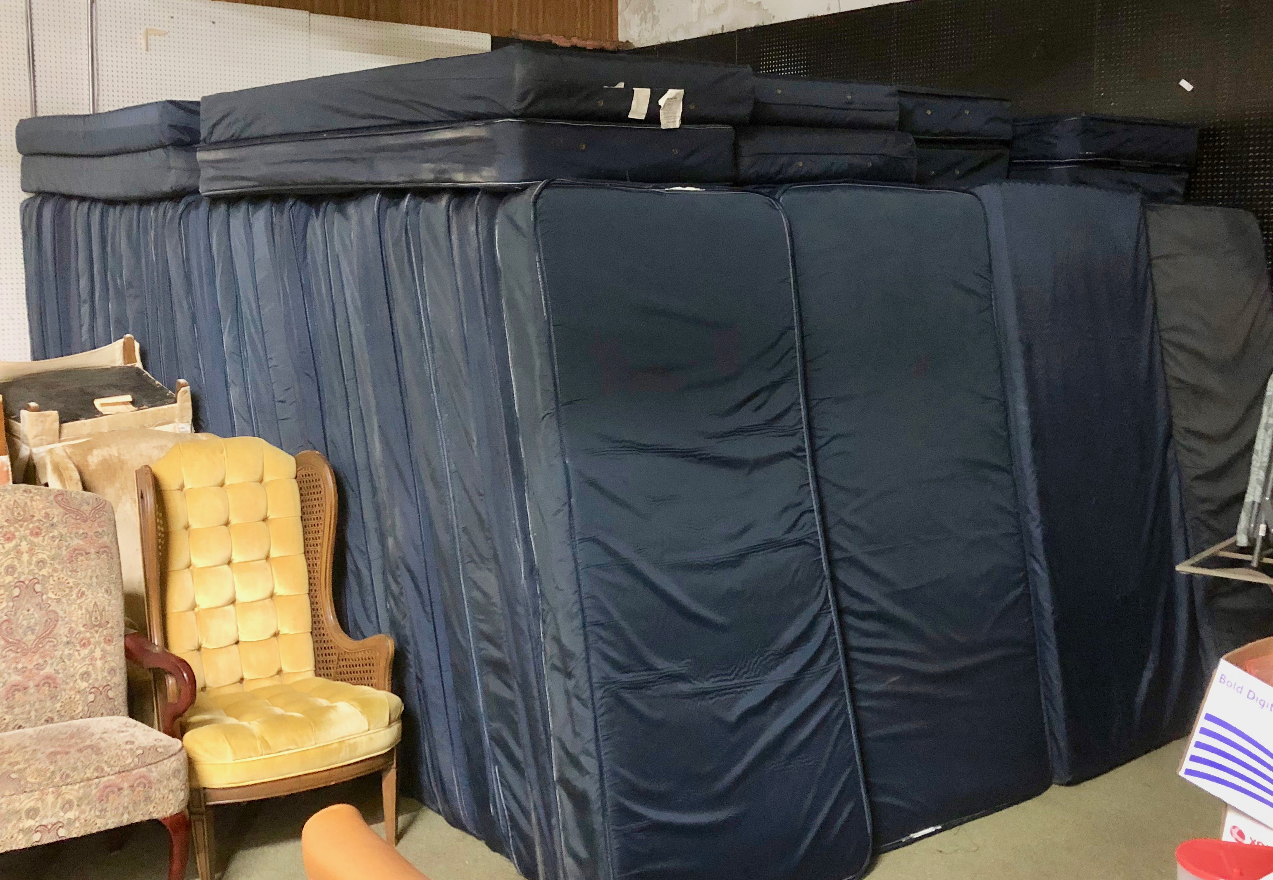
When we have the chance to love, serve and befriend international students in the name of Jesus, we are interacting with the next generation of leadership throughout the world, and we have the chance to point them in the direction of Jesus while they are here. We have seen the light of understanding flipped on for so many students and visiting scholars, as they hear about him, and the fullness of joy enter their hearts as they come to know and follow him. Please pray intently for every student and scholar seeking Jesus!

Huge answer to prayer

In 2019, we had a record year for furniture donations. We made 250 furniture pickups throughout the year and have had lots of furniture to give students… except single mattresses. Good condition single mattresses are just hard to come by. Usually, by the time people are donating a single mattress, it has been well jumped on and can be quite stained and unusable. This fall we had a huge number of new international students arrive (411, which may be a record). We were able to give them everything they needed, except we ran out of mattresses.

On December 31, God had restocked our warehouse, except we only had two single mattresses to give to the 75-100 new students arriving in January. We prayed and asked God to give us single mattresses, and I contacted the head of Residence Life at UT, asking if he had even 10-20 mattresses in storage he could spare. He told me that they just happened to be clearing out one of the dorms, and he welcomed me to come and take the mattresses. It took four volunteers and two trucks two days with multiple pickups, but through this God provided 180 mattresses!
Wellspring Ministries wdbbdw@aol.com 419-478-8325

ASSOCIATION OFFICERS

Moderator: Rick Morris (Hope of Glory)
Vice moderator: Lance Wyse (Haven Hts)
Members at large: Ray Gaffney (Galilee)
Shawn Alldredge (FBC Oregon)
Matt Pardi (H2O BG)
Treasurer: Jeff Woolum (FBC Perrysburg)
Clerk: Janet Bartus (Gateway)

ASSOCIATION OFFICE MOVED
New location: Gateway Baptist Church 6047 Dorr Street, Toledo 43615 Mailing address is: PO Box 962, Toledo 43697

Check out the summer camps at
Family camp – June 1-5
Missions Adventure – June 8-12
Kids Kamp – June 15-19
Kids Kamp – June 22-26
Camp U Can – June 27-July 3
Mystery Youth Camp – July 6-10
Mystery Youth Camp – July 13-17
Mystery Youth Camp – July 20-24
Go to www.scbo.org/slba-events for details.

