Northwest Ohio Baptist Association
“KINGDOM CONNECTIONS”
August 2019

NW Ohio Churches on Mission to Reach One Million One Life at a Time

MISSION TRIP TO NASHVILLE
In June we (Haven Heights, Wauseon and First Baptist, Perrysburg) had the opportunity to be on mission in Nashville Tennessee, where we partnered with the Nashville Baptist Association.
We left on Sunday June 23, and began work at the associational building the very next day. During the next five days we painted a stairwell and shed. We also prepped a parking lot for resealing, and helped with office organization and filing.
On Tuesday evening we began helping with the Burmese Pastor’s Conference. During the evening session, our team coordinated activities for the Burmese children for three nights. We had Bible lessons, played games, made crafts, and had snacks.
One interesting thing we learned is that 206 years ago, Adoniram Judson set sail from America to Burma. In Burma Judson translated the Bible into their native language and to this day most every Burmese pastor can trace their spiritual lineage back to his ministry.
Our efforts were not nearly as costly as Judson’s. We were only gone a week. We didn’t travel half way around the world. And yet we were able to participate in the making of disciples, of other nations. May God’s fame be spread, and may he be glorified. Pastor Lance Wyse
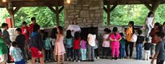
Pastor Gin Piang of
the United Zomi Baptist
Church said the
pastors and wives
were thrilled to have
their children taught by English speaking Christians and that the whole experience was a true blessing. Pastor Gin reported a total attendance of 250, including 89 Zumi language pastors from around the United States and 11 coming from Burma for this conference.

#NO PLACE LEFT training
The Command of Christ.
Equipping a follower of Jesus to simply obey His commands.
October 25 & 26, 2019
Southern Missionary Baptist Church
1222 Indiana Ave, Toledo
For additional information go to: mynwoba.com
Resources

NORTHWEST OHIO BAPTIST ASSOCIATION
PO Box 962, Toledo 43697
402 South Avenue, Toledo 43609
419-243-1255 MYNWOBA.COM

The Disciple House
People being the Kind of Church Jesus Came to Create
925 S. Clinton St. Suite 1-1044, Defiance, OH 43512
419-439-3783 johncattell@rocketmail.com

This is an excerpt from a devotional, The Book of Mysteries by Jonathan Chan, that is being sent to prison inmates. Pray for the men and women that receive these devotionals that they would “turn to the Spirit”.

He took me to an open desert plain. It was a windy day, so windy it was almost violent.
“Come,” said the teacher. He was asking me to walk against the wind’s blowing, so I did.
“What is it like to walk against the wind?” He asked.
“It’s a struggle,” I replied.
“In the language of Scripture,” He said, “the word for wind is ruach. But it has another meaning; it also means the Spirit. In
Hebrew the Holy Spirit is the Holy Wind. So what happens if you walk against the wind? It creates drag, it becomes harder to walk and you get tired. In the same way, He said, when you walk against the Spirit, it creates a drag against your life. Everything you do becomes harder. It takes more energy to do less. So when you go against His Spirit, you’re fighting against the Wind. And you can’t walk against the direction of the Wind without getting weary and worn out. And what way is the direction of the Wind, the Spirit? The Spirit is the Holy Spirit. Therefore it blows in the direction of the holy, and blows against the direction of the unholy. Now try something else. Turn around and walk back, the same way you came.”
So I did. I was now walking in the direction of the wind’s blowing.
“And what was that like?” He asked.
“It was much easier,” I said.
“That’s because there was no drag,” He said. “You were walking in the direction of the wind. And the wind helped you walk. It moved you ahead. It made your walking easier. So when you walk against the wind, it creates a drag. But, if you turn, the wind gives you power. So it is with the Spirit. If you turn, if you change your course, if you repent, if you walk in the Spirit, then the drag will disappear. The Spirit will empower you and will move you forward. And then everything you do, that you must do, will become easier.”
“So if you walk in the Spirit,” I said, “life will go from a drag…to a breeze.”
“Yes,” said the teacher. “For those who walk in the Spirit…the Wind is at their back.”

THE MISSION: What part of your life is against the direction of the Spirit? Today, turn it around and start walking with the Wind at your back. John 3:8; Acts 2:2; Galatians 5:16-17

John and Kay Cattell
As I sit down to write this my mind spins with an attempt to sum up the events of the last six months. It’s been crazy! We were faced with the likelihood of coming up short on funds and then at the very last hour a loving local church stepped in to bail us out. Their great generosity combined with the ongoing generosity of those who faithfully sustain monthly giving, allow us to continue to grow, and to serve more and more of those who are in need.

We have continued to increase not only the services we provide but also the amount of product we can give and the number of clients we are able to serve. God is awesome. We still need every help we can get to reach people with the love that God intends to use to overcome evil in Toledo and our opportunities to do so continue to increase in number.

An estimate - which is still underway - seems to say that we have served over five percent of the households in Toledo since fall of 2013. The number of people is escalating every week.

We have two upcoming fall fund raisers and are hoping to supplement the 2020 budget. The golf outing is September 7th and we are still praying for more sponsors and players. The cost of $80 for 18 holes of golf, a steak dinner, and a $10,000 hole-in-one contest is very reasonable and all proceeds go directly to overcoming evil in Toledo thru the Life Station.

We continue to need volunteers, speakers (must be Southern Baptist,) prayers, and donations of all kinds (feel free to send a check or your plastic bags and all things in between.)

I thought I would do something a little different for an ending and focus completely on the labor side for a closing.

Volunteer tasks currently open include: Speaking at a Monday service, sing a special at a Monday service, filling grocery bags, shopping for bargain prices, sorting and hanging clothes, making phone calls, mailing letters, and working a tablet to help sign people in. This is a very short list compared to the ongoing need. Please consider if God may be calling you to help this ministry and in what capacity. Thank you. Pastor Dan Stevenson
#overcomingevil
Serving at 402 South Ave., Toledo
419-242-3340
Mailing address: PO Box 962, Toledo 43697
overcomingevil@bex.net
To give: text LSGIVE to 4194190095
To partner: text PARTNER to 4194190095

SCHOLARSHIP RECEPIENTS
Amalya Hartley of New Heights Fellowship Baptist Church
Lacey Hayes of H2O Bowling Green City Church

The scholarship is through the James Eldredge Scholarship fund. It is awarded for 2 semesters at $500 per semester.
Applications for Fall 2020 must be received by June 1, 2020. A request for an application can be made through the Association website, call the office 419-243-1255 or janetbartusnwo@gmail.com

Angels and endurance
…being strengthened with all power, according to his glorious might, for all endurance and patience with joy.
~~ Colossians 1:11 ~~
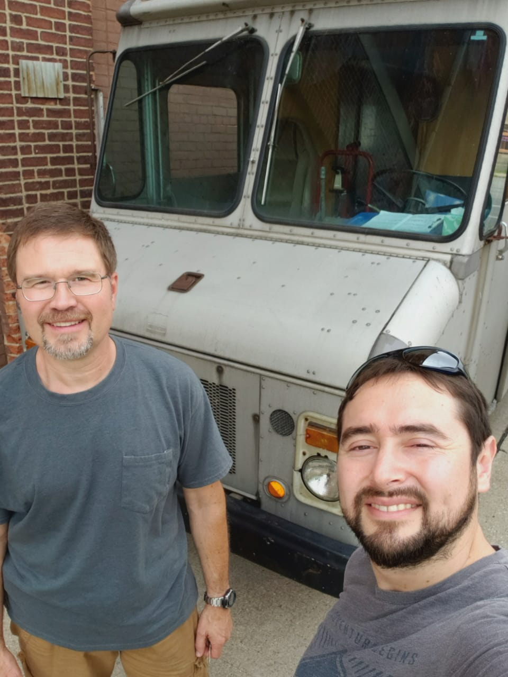
It was a hot and sweaty afternoon, during the heat-spell a number of weeks ago. I had been moving furniture in my truck and was late to my next appointment, but was low on gas. At one of the busiest intersections in Toledo, I pulled into an over-priced gas station and put about 5 gallons in my old truck, intending to completely fill the tank later.
I pulled out of the station and stopped at the light. When the light turned green, and I tried to go, all of a sudden the engine sputtered and died. As I tried to restart it, it acted as though the battery was low and after only a few attempts, the battery died! People were honking at the intersection and I was already late, wondering what I would do next. Just as I was about to give up in frustration, call and cancel my appointment, and call a tow-truck, a woman named Sara walked up to my truck. She works in the international student office and she recognized my truck. It just so happened she was also getting gas at that same time. She happened to have jumper cables and was able to help me get my truck started. God supplied an “angel” at just the right moment!
Jesus whispered in my ear, “I’m watching over you. Don’t give up.” According to the verse above, God strengthens us for endurance and patience, but not so that we can grumble our way through problems. Part of that endurance is joy. As we are going through the struggles of life, the people around us need to see our joy, especially when we are going through difficult times. Literally “the joy of the Lord is our strength.”
Later on, my mechanic replaced my alternator which was producing less than 12 volts, my battery which had a bad cell, my fuel pump which literally fell apart in his hands when he removed it, and an accelerator pump in my carburetor. My truck now runs better than it ever has, and God allowed it to fail before our crazy-busy season started, so the truck would be ready to handle the workload.
PRAISE AND PRAYER POINTS
•“Farrokh” came for a visit over the July 4th weekend and stayed with us. We had a great chance to sow into his life and to do some more Bible study. Pray for him as he continues to do his “co-op” in another city.
•We said goodbye to “Sue” who attended our Bible study for 9 months. Pray intently for her that God will connect her with other believers in her home city.
•Thank you for praying! God has supplied much of what we need for new students arriving. We did receive quite a number of mattresses, but still need a few dining tables.
•Praise God for a young woman named “Hope” who attends a local church. A couple of years ago, Grace’s mom had an Asian Conversation Partner, and she and Hope became friends, talking frequently about Jesus. The Asian student returned home and Hope recently traveled to Asia to see her and continue her faith conversations!
•Please continue to pray for us financially. Several people responded to our need in June and a couple others in July, but we are still not meeting budget. We are thankful for all of you who respond to the prompting of the Lord to support us financially. You are part of reaching the world!
•Pray for God to supply all the Conversation Partners and Host Families that will be needed to reach out to students. Pray for a season of response as I speak in many churches.
Serving alongside you in His steps,
Wellspring Ministries wdbbdw@aol.com 419-478-8325
We are trying to be good neighbors to the Toledo Gospel Rescue Mission, who owns the furniture warehouse that we use. We are trying to cover 1/3 of their regular monthly expenses for the building. If you or your church is interested in financially supporting the warehouse funding project, we are looking for a handful more donors to support it at only $25-50 a month! That’s a small monthly investment that impacts more than 600 international students a year. There are dozens of international students who are now believers, and their first contact was furniture through the Household Items Giveaway! Please contact me if you would like to know more. Wes

SOUTHSIDE LIFE STATION GOLF OUTING
Saturday, September 7 Noon
Maple Grove Golf Course, Secor Rd, Lambertville, MI
18 Holes/cart/steak dinner/door prizes
$10,000 Hole in One Contest
Please register and pay in advance ($80/person; $300/foursome) by August 15.
Text: GOLF to 4194190095 to receive a link to register and/or for sponsorship.
Contact Dan Stevenson 419-469-0270 for questions

ASSOCIATION ANNUAL MEETING
MONDAY, OCTOBER 7 at First Baptist, Perrysburg
6 PM - Light supper
6:45 PM - Worship, Special Speaker, Business

CHANGES IN THE ASSOCIATION
Pastor John Gaskill of Reynolds Corners Baptist Church has retired and moved to the Pemberville area.
Gateway Baptist Church has purchased the church property.

WHO’S YOUR ONE?
Is there one person in your life that you can pray for, witness to, spend time with so that
that ONE will come to know Jesus as their Lord and Savior?
For some help in getting started go to: whosyourone.com

WOMAN’S MISSIONARY UNION
Hello from NwOBA WMU!
It is still summer and are we not glad! Even though we have had some hot weather, winter is not yet encroaching upon us!
In June I was honored to be at training in Columbus with 20 ladies from across the state. Three ladies from Galilee Baptist Church in Defiance, surprised me by attending! Our trainer, Claudia Johnson from National WMU, was a definite encouragement. A special treat for me was that I had just finished an on-line course which Claudia led through the Christian Women’s Leadership Center, so I was able to meet her in person. A delight! The event was of great value!

Our state Baptist women are once again putting together filled backpacks for Appalachia to distribute as Christmas gifts to children. Twenty-five backpacks have been given out to ladies in our association and I am so happy for the interest.

At the annual association picnic at Strawberry Acres, it was a joy to connect with so many women who attended. Ladies from The Movement Church, Primera Iglesia Baptista, Gateway Baptist Church, Galilee Baptist Church, FBC Perrysburg, Mt. Calvary Baptist Church, H2O Church, New Heights Fellowship, and FBC Oregon were present. Several conversations involved the backpack ministry, mission education opportunities, and prayer for missionaries.

On September 6-7 our Women’s Fall Retreat and Mission Celebration will be held at Seneca Lake Camp in Senecaville, Ohio. Kristy Carr from National WMU, will be the main speaker with worship, workshops, fellowship time, food and activities for those who attend! Four of the women who went on mission from Ohio will also be sharing about their trips to Nicaragua and Kenya. If you want more information, search the scbo.org/women’s resources link, or contact me.

At our November State Convention of Baptists in Ohio annual meeting, our luncheon for pastor wives and women in ministry will have the opportunity to hear from Cathy Pound who will have returned from two months of ministry in Kenya, sleeping in a tent with a hole in the ground and threat of elephants passing by (yikes!), sharing the gospel with those who live in the ‘bush’ area of Kenya! It will be an amazing presentation. Please plan to come to Rolling Hills Baptist Church, Fairfield, Ohio!

I look forward to meeting more of you in the future and some from our ‘new’ churches that have joined our association. Plans are in the works for two WMU gatherings in different parts of our association. More information to come! If you are interested in helping with planning, please contact me!

May God richly bless you and those God sends your way,

Teresa Bailey, WMU leader, tlb31@amplex.net 419-308-3477

Pray for our kids heading back to school. Pray for their teachers.

